INTRODUCTION

Internet usage is one of the most required services in the 21st century. The world without internet can be very challenging. This project is to identify key information regarding internet usage around the globe. The data is about internet usage, cost and speed across 200+ countries. And the data is collected from various sources in the internet. The project is focusing on answering some questions outlined. The project gives some inputs to global internet providers, analysts, experts in internet services etc…

EXECUTIVE SUMMARY
The given screenshot of Tableau dashboard is the final analysis result.
Link to Tableau dashboard :- (https://public.tableau.com/views/worldwideinternetusersanalysis/worldwideinternetusersanalysis?:language=en-US&:display_count=n&:origin=viz_share_link
)
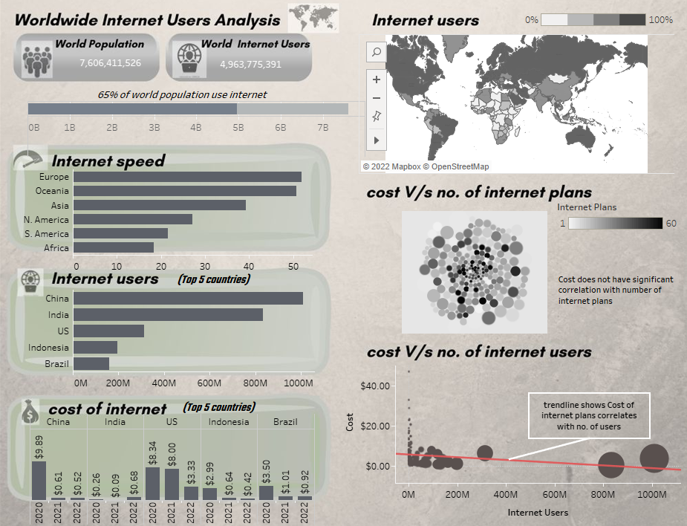

QUESTIONS

- What is the percentage of world population use internet?
- Top 5 countries in terms of number of internet users
- What percentage of population use internet categorised by continent?
- Which continent with highest share of internet users?
- Does number of internet plans correlate with cost of plans?
- Is there any huge difference in average internet speed in continents?
- Does every country in a continent have same internet speed? Or varies heavily?
- How the cost of internet plans in 2020, 2021, 2022 over countries? (let’s take top countries as sample)
- Does the cost of plans correlates with number of internet users?
- Are there any countries with less than 50 % of population use internet?

HYPOTHESIS
My assumptions on the analysis are as follows:-

- Around 75% of world population use internet
- I assume US, China, Australia, India and Germany are the highest in rank when counting number of internet users
- I assume over 70% of population use internet over continent wise0000.doc
- Asia would be having highest share of internet users
- I think number of internet plans highly correlates with cost of plans
- I assumes Europe and North America have high internet speed and Asia and Africa will be lowest with significant difference
- My hypothesis on speed among countries in same continent would be around same value
- There wouldn’t be any difference in cost of internet plans among the top countries during these years
- There would be significant relationship between cost of internet and number of internet users
- I assume there is no country with internet users which is less than 50% of population

DATA CLEANING

Before the analysis I have done the cleaning the data. Below I have provided screenshots of the description and steps in data cleaning.

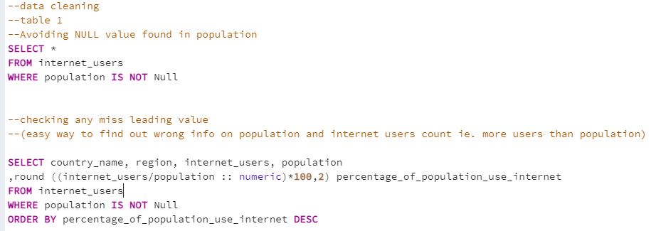
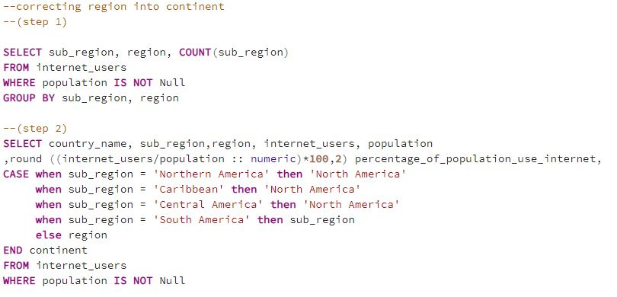

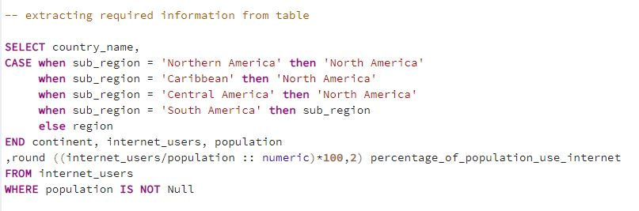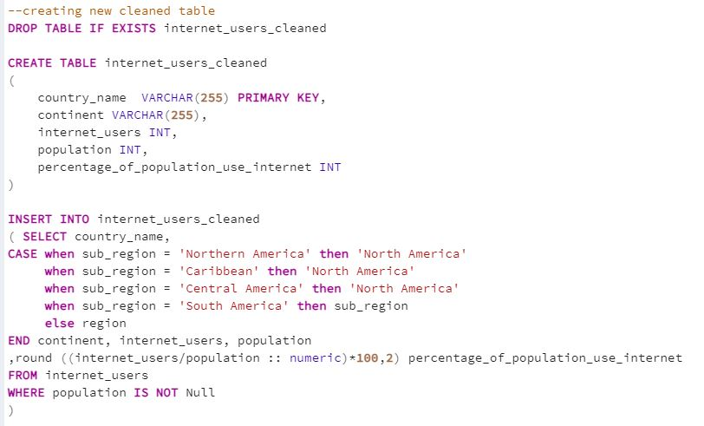

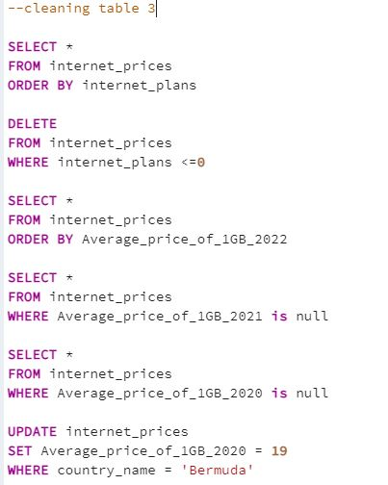
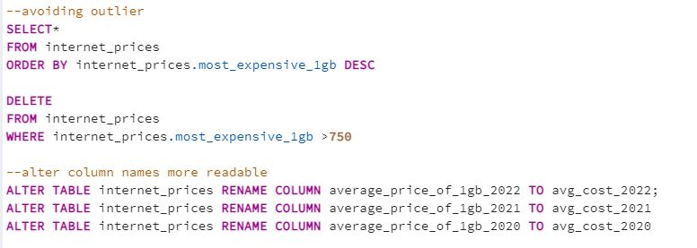
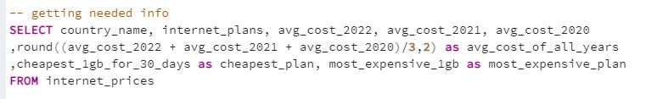
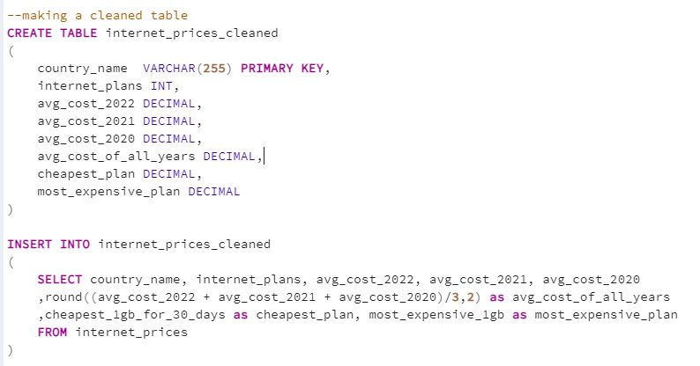

DATA ANALYSIS

After the data cleaning, I have conducted analysis of the data. Below I have provided the screenshots of SQL queries for analysis and screenshots of the visuals of the analysis from Tableau.

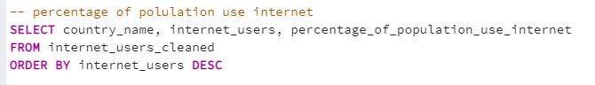

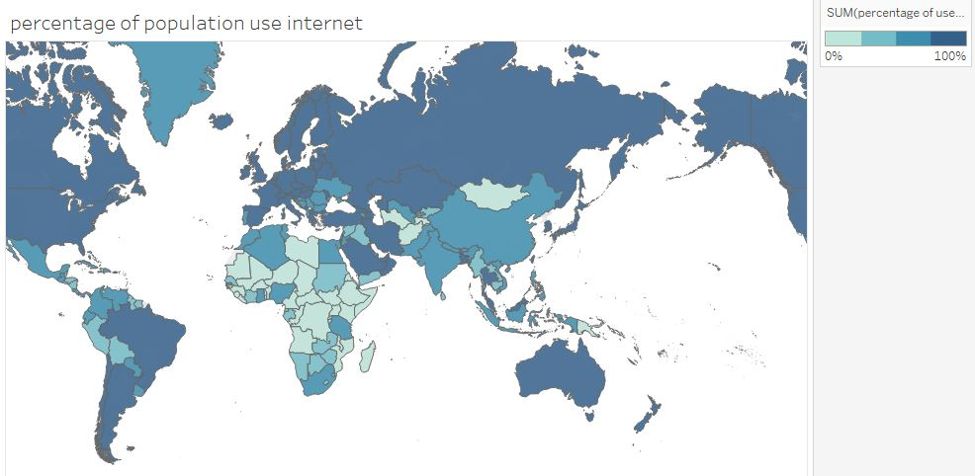
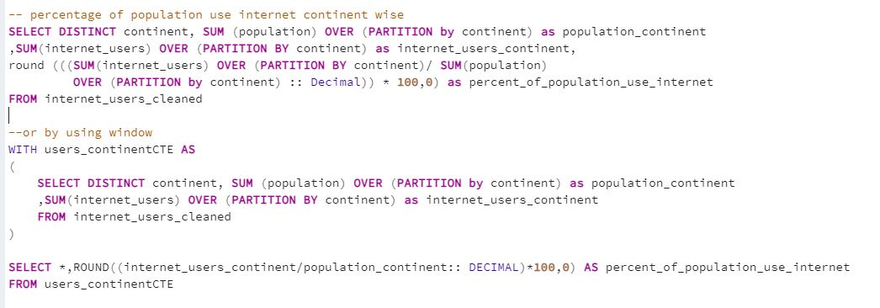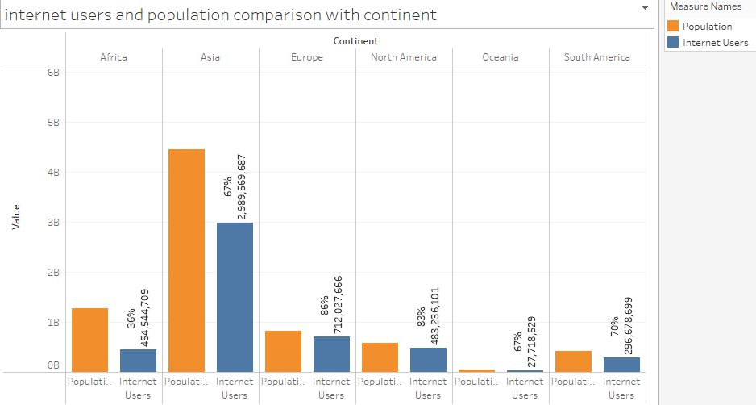

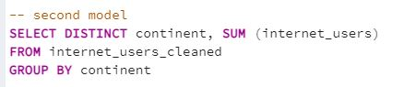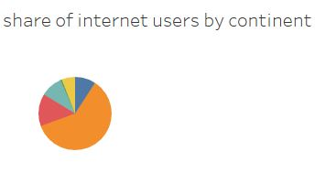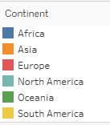
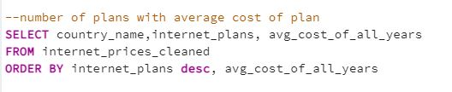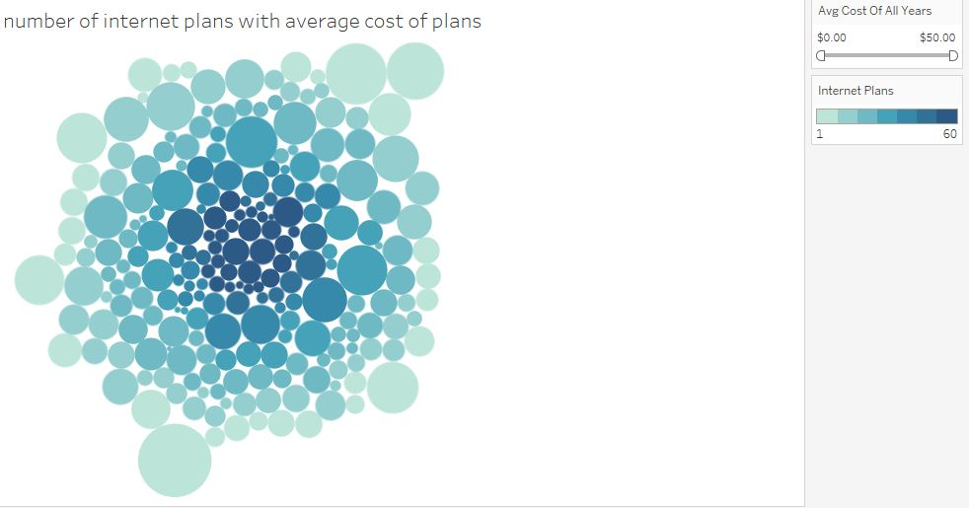

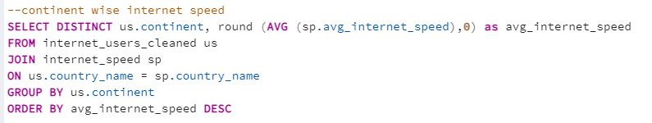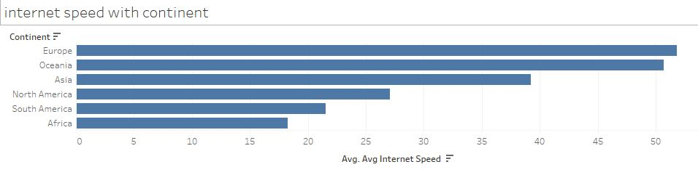

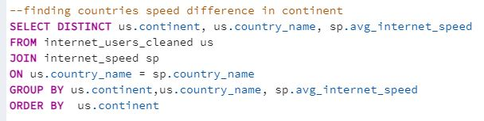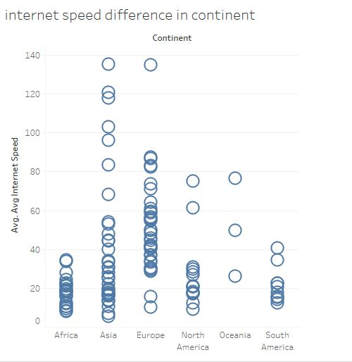

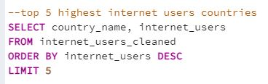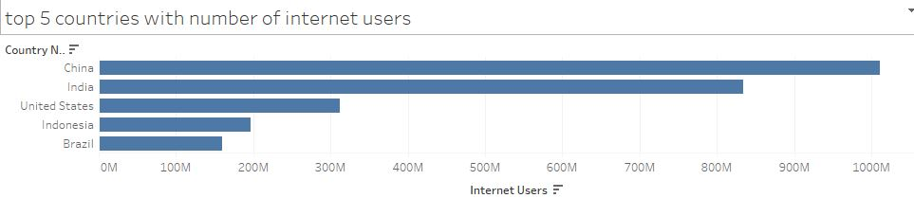
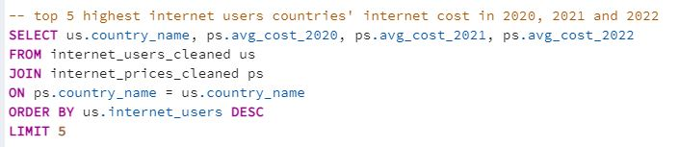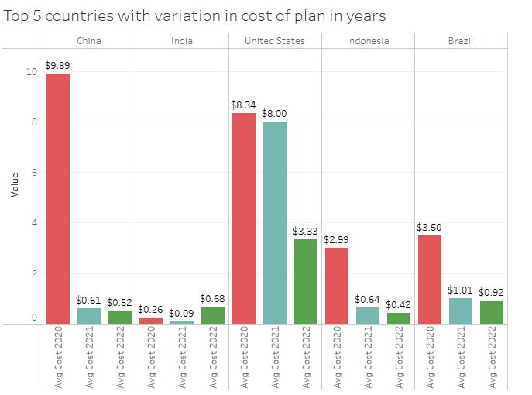

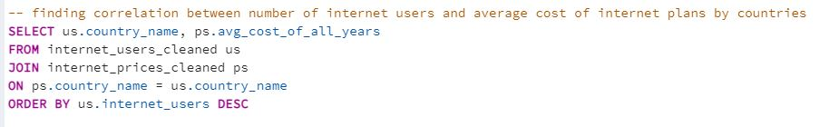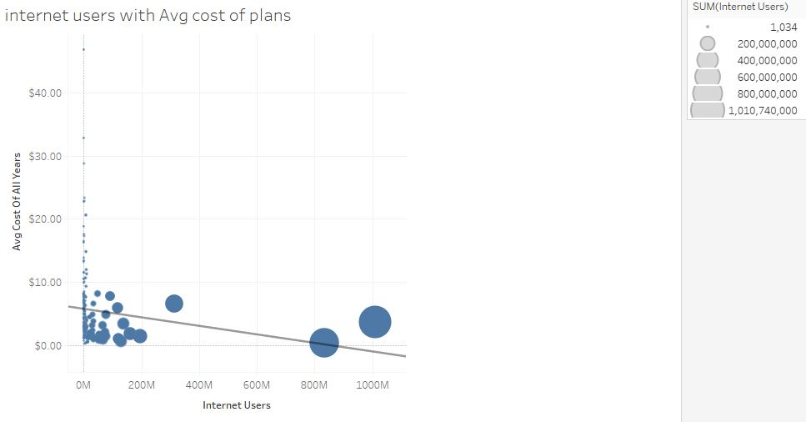
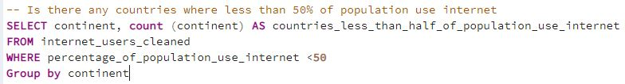

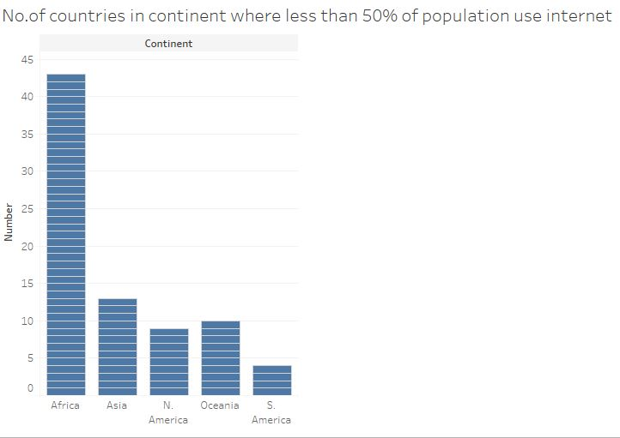
FINDINGS
Around 65% of world population use internet. The analysis shows China, India, US, Indonesia and Brazil are the highest in order of internet users’ count. Even though Europe, North and South America have above 70% internet users over population, Asia has more numbers than these continents combined. Asia has highest share of internet users which is more than half of total. There is no significant correlation between number of internet plans and cost of plans.
Europe, Oceania and Asia have more than 39 (Mbit/s)Ookla while rest of the continents between 18-27 (Mbit/s)Ookla The result shows that except Africa, countries vary in internet speed among the continents. Importantly, Asian countries internet speed values have scattered throughout the graph. There is an outstanding difference in cost of internet over the period in countries like China, US, Brazil and Indonesia. However, in 2022, except US, all countries cost of internet comes around same value. The trendline shows the notable relationship between cost of internet and number of internet users. Most surprisingly, 77 countries’ internet users are only less than 50% of population.

Here I show the result of analysis (screenshot of Tableau dashboard):

